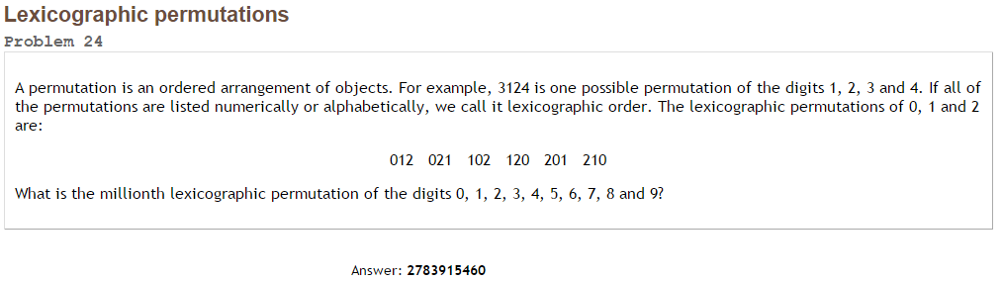Project Euler #24 – Pen & Paper Solution

There are  permutations total.

In the first  permutations (lexicographic order), the leading digit is 0,

In the next, the leading digit is 1, etc…

Following that pattern:

|  |  |  |  |  |
| --- | --- | --- | --- | --- |
| Remainder: | Block Size: | Blocks Passed (Q): | Remainder in Block (R): | Digit Used: |
| 999999 | 362880 | 2 | 274239 | 01<2>3456789 |
| 274239 | 40320 | 6 | 32319 | 013456<7>89 |
| 32319 | 5040 | 6 | 2079 | 013456<8>9 |
| 2079 | 720 | 2 | 639 | 01<3>4569 |
| 639 | 120 | 5 | 39 | 01456<9> |
| 39 | 24 | 1 | 15 | 0<1>456 |
| 15 | 6 | 2 | 3 | 04<5>6 |
| 3 | 2 | 1 | 1 | 0<4>6 |
| 1 | 1 | 1 | 0 | 0<6> |
| 0 |  | 0 | 0 | <0> |

1000000th permutation is: 2783915460